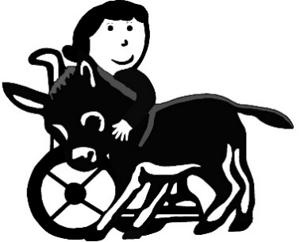
Thera-Pets, Inc.
362 Peasleeville Road Schuyler Falls, NY
518-643-2577 (Holly) 518-569-1263 (text)

Donkeys & Friends Animal Assisted Therapy
We would like to welcome you to Donkeys & Friends group. Please only sign your child up if you can commit to the group. If for any reason you can’t attend call Holly at 518-643-2577 or text 518-569-1263. If we are not notified for two weeks we will consider your children dropped from the group.

Safety Concerns and Rules!

- If you arrive late please wait for the next activity to begin.
- Please walk at all times while on the Farm!
- Please do not climb on gates or over fences.
- Please do not open any gates without a trained volunteer.
- Animals do not like to be chased so we ask that you not run up
to them, let them come to you.
- Children must be accompanied by a volunteer when in any of the animals
areas.
- Our donkeys are used as therapy animals and we ask that you
not feed them from your hand.
- All farm equipment is not safe to be on.
- Please have your child sit down when holding the bunny.
- Please dress for farm conditions, boots, coats, old clothes.
- NYS now has inherent risk, If you enter into the areas you are assuming the risk
- We also require a signed photo release expressing your wishes
for children and family members to be photographed & or
videotaped.
- Please provide us with your current contact information.
- Please use hand cleanser before entering the farm and before
leaving.
Rules are kept to a minimum, but they are for everyone’s safety.
If you have a concern or suggestion about your child, or the group as a whole, please let us know. We are learning every day and want this to be a wonderful experience for your child. We welcome feedback.

We hope you will have a safe and enjoyable experience!!

